**“360-DEGREE BUSSINESS ANALYSIS OF ONLINE**

**DELIVERY APPS” “ST JOHNS COLLEGE"**

|  |  |
| --- | --- |
| **NM ID** | **NAME** |
| 5E37785BD2769BE88D14859AC2910961 | SWETHA J |

|  |  |
| --- | --- |
|  |  |
| R. UMA MAGESHWARI | Trainer Name |

|  |  |
| --- | --- |
| R. UMA MAGESHWARI | Master Trainer |

ABSTRACT

Online food delivery apps have revolutionized the way we eat, offering convenience and a vast selection of restaurants at our fingertips. This abstract explores the key aspects of this booming business mode:The analysis dives into the Indian online food delivery landscape, outlining customer preferences, competition (Swiggy, Uber Eats etc.), and current trendsUnderstanding customer behavior is crucial. We'll examine who uses these apps, their ordering habits, and what factors influence their restaurant choices.:The value proposition for restaurants will be explored, including how they benefit from app visibility, commission structures, and marketing potential.A user-friendly app is essential. We'll assess the ease of use, ordering process, restaurant discovery features, and available payment options.The analysis will explore Zomato's revenue streams, such as commissions and subscription services (Zomato Gold), alongside their cost structure (marketing, logistics).The abstract concludes by identifying potential challenges and opportunities, considering technological advancements, competition, and regulatory changes.

### INDEX

|  |  |  |
| --- | --- | --- |
| **Sr. No.** | **Table of Contents** | **Page No.** |
| 1 | Chapter 1: Introduction | 4 |
| 2 | Chapter 2: Services and Tools Required | 6 |
| 3 | Chapter 3: Project Architecture | 7 |
| 4 | Chapter 4: Modeling and Result | 9 |
| 5 | Conclusion | 18 |
| 6 | Future Scope | 19 |
| 7 | References | 20 |
| 8 | Links | 21 |

**CHAPTER 1**

# Problem Statement

### INTRODUCTION

Zomato's online delivery app has transformed the food industry, but faces challenges in a competitive market. This analysis aims to identify areas for improvement by examining customer behavior, restaurant partnerships, app functionality, and financial performance. Can Zomato optimize its app and operations to enhance user experience, attract more restaurants, and achieve sustainable growth?

# Proposed Solution

Analyze Zomato's delivery app to optimize growth:Conduct market research to understand customer trends and competitor strategies.Analyze user data to improve user experience and target marketing efforts.Partner with restaurants to develop mutually beneficial commission structures.Evaluate app functionality to ensure a smooth user experience.Analyze financials to identify revenue opportunities and cost efficiencies.Identify future challenges and opportunities to solidify market position.By implementing this analysis, Zomato can gain valuable insights to strengthen their app and business.

# Feature

A business analysis of an online delivery app like Zomato should consider a variety of features to provide a comprehensive picture. Here are some key aspects to include:

Customer-Centric Features:User Experience (UX) Analysis: Evaluate the app's ease of use, navigation, search functionality, and overall design.

Customer Segmentation: Identify different user groups and their ordering habits (frequency, preferred cuisines etc.).

Customer Acquisition and Retention: Analyze strategies for attracting new users and keeping existing ones engaged (promotions, loyalty programs).

Restaurant-Centric Features:Onboarding and Partnership Analysis: Evaluate the process for restaurants to join the platform and the value proposition offered (increased reach, marketing opportunities).

Commission Structure Analysis: Assess the fairness and competitiveness of commission rates charged to restaurants.

Restaurant Performance Analysis: Identify metrics used to track restaurant performance on the platform (delivery times, customer reviews etc.).

Logistics and Delivery Management: Analyze the efficiency of Zomato's delivery network, including delivery partner management and order fulfillment times.

Technology Infrastructure: Evaluate the scalability and reliability of the app's underlying technology.

Data Analytics: Assess Zomato's ability to utilize data to optimize operations, personalize user experiences, and target marketing efforts.

* Advantages

Boost Customer Satisfaction: By understanding user behavior and preferences, Zomato can improve the app's features and functionalities to make the ordering process smoother and more enjoyable. This can lead to higher customer satisfaction and loyalty.

Optimize Restaurant Partnerships: Analyzing data can reveal which restaurants are most popular and profitable. This allows Zomato to develop targeted marketing campaigns and commission structures that benefit both Zomato and the restaurants.

Drive Revenue Growth: Identifying revenue streams with high potential and areas where costs can be reduced allows Zomato to maximize profits. Additionally, understanding customer behavior can help personalize marketing efforts, leading to more orders and increased revenue.

Gain a Competitive Edge: Analyzing competitor strategies and market trends allows Zomato to stay ahead of the curve. This can involve implementing innovative features, offering unique delivery options, or targeting specific customer segments that competitors might be overlooking.

Make Data-Driven Decisions: Business analysis moves decision-making from intuition to a data-driven approach. This ensures that resources are allocated strategically for maximum impact, leading to more effective marketing campaigns, app improvements, and overall business strategy.

Prepare for the Future: By understanding current trends and potential challenges, Zomato can proactively adapt its business model to changing market conditions and technological advancements. This future-proofing helps Zomato maintain its position as a leader in the online delivery market.

In conclusion, business analysis equips Zomato with valuable insights to optimize its app, strengthen restaurant partnerships, and ultimately achieve sustainable growth in the competitive online delivery landscape.

# Scope

Industry and Market Analysis:

Customer trends: Analyze customer preferences, including ordering frequency, preferred cuisines, and delivery expectations.

Competitive landscape: Identify key competitors (Swiggy, Uber Eats etc.), their strengths and weaknesses, and their market share.

Regulatory environment: Stay updated on regulations impacting delivery services, such as licensing requirements and data privacy laws.

Customer Analysis:Customer segmentation: Identify different user groups based on demographics, ordering habits, and value preferences.

Customer journey mapping: Analyze the entire customer experience, from app discovery to order placement and delivery.

Customer satisfaction: Measure user satisfaction through surveys and reviews to identify areas for improvement.

Retention strategies: Develop strategies to retain existing customers and increase order frequency.

Restaurant Analysis:Restaurant value proposition: Analyze how Zomato benefits restaurants (increased reach, marketing opportunities, etc.).

Commission structure: Evaluate the commission structure for restaurants and its impact on their profitability.

Onboarding and training: Assess the process for onboarding restaurants and providing them with training on the platform.

Restaurant satisfaction: Measure restaurant satisfaction with Zomato's services and identify areas for improvement.

App Functionality Analysis:User interface (UI) and user experience (UX): Evaluate the ease of use, navigation, and overall user experience of the Zomato app.

Ordering process: Analyze the efficiency and clarity of the ordering process, including menu browsing and checkout.

Restaurant discovery features: Assess the effectiveness of features that help users find restaurants, such as search filters and recommendations.

Payment options: Ensure the app offers a variety of secure and convenient payment methods.

Financial Performance Analysis:Revenue streams: Identify all sources of revenue for Zomato, including commissions, delivery fees, and subscription services (Zomato Gold).

Cost structure: Analyze the breakdown of Zomato's costs, such as marketing, logistics, and technology maintenance.

Profitability: Evaluate the overall profitability of Zomato's online delivery business. Growth opportunities: Identify potential new revenue streams or cost-saving measures.

Future Considerations:Technological advancements: Analyze how emerging technologies like AI and automation can improve the delivery process.

Sustainability: Explore ways to make the delivery process more sustainable, such as promoting eco-friendly packaging options.

Competition: Develop strategies to stay ahead of the competition by offering innovative features and superior customer service.

By comprehensively analyzing these areas, Zomato can gain valuable insights to optimize their online delivery app, strengthen their market position, and achieve sustainable growth.

### CHAPTER 2

**SERVICES AND TOOLS REQUIRED**

#### Services Used

* + - **Data Collection and Storage Services**: Banks need to collect and store customer data in real-time. This could be achieved through services like Azure Data Factory, Azure Event Hubs, or AWS Kinesis for real-time data collection, and Azure SQL Database or AWS RDS for data storage.
    - **Data Processing Services**: Services like Azure Stream Analytics or AWS Kinesis Data Analytics can be used to process the real-time data.
    - **Machine Learning Services**: Azure Machine Learning or AWS SageMaker can be used to build predictive models based on historical data.

#### Tools and Software used

##### Tools:

* + - **PowerBI**: The main tool for this project is PowerBI, which will be used to create interactive dashboards for real-time data visualization.
    - **Power Query**: This is a data connection technology that enables you to discover, connect, combine, and refine data across a wide variety of sources.

##### Software Requirements:

* + - **PowerBI Desktop**: This is a Windows application that you can use to create reports and publish them to PowerBI.
    - **PowerBI Service**: This is an online SaaS (Software as a Service) service that you use to publish reports, create new dashboards, and share insights.
    - **PowerBI Mobile**: This is a mobile application that you can use to access your reports and dashboards on the go.

### CHAPTER 3 PROJECT ARCHITECTURE

#### Architecture

**USER FRONTEND BACKEND**

|  |  |  |
| --- | --- | --- |
|  | **HTML 5** | **NODEJS 14.0**    **Database** |

Here’s a high-level architecture for the project:

* + - **Data Collection**: Real-time customer data is collected from various sources like bank transactions, customer interactions, etc. This could be achieved using services like Azure Event Hubs or AWS Kinesis.
    - **Data Storage**: The collected data is stored in a database for processing. Azure SQL Database or AWS RDS can be used for this purpose.
    - **Data Processing**: The stored data is processed in real-time using services like Azure Stream Analytics or AWS Kinesis Data Analytics.
    - **Machine Learning**: Predictive models are built based on processed data using Azure Machine Learning or AWS SageMaker. These models can help in predicting customer behavior, detecting fraud, etc.
    - **Data Visualization**: The processed data and the results from the predictive models are visualized in real-time using PowerBI. PowerBI allows you to create interactive dashboards that can provide valuable insights into the data.
    - **Data Access**: The dashboards created in PowerBI can be accessed through PowerBI Desktop, PowerBI Service (online), and PowerBI Mobile.

This architecture provides a comprehensive solution for real-time analysis of bank customers. However, it’s important to note that the specific architecture may vary depending on the bank’s existing infrastructure, specific requirements, and budget. It’s also important to ensure that all tools and services comply with relevant data privacy and security regulations.

### CHAPTER 4 MODELING AND RESULT

**Manage relationship**

The “disp” file will be used as the main connector as it contains most key identifier (country,kpi,restaurant name) which can be use to relates the 8 data files together. The 'restaurant name' file is use to link the country zomato app geographically with “restaurant id”

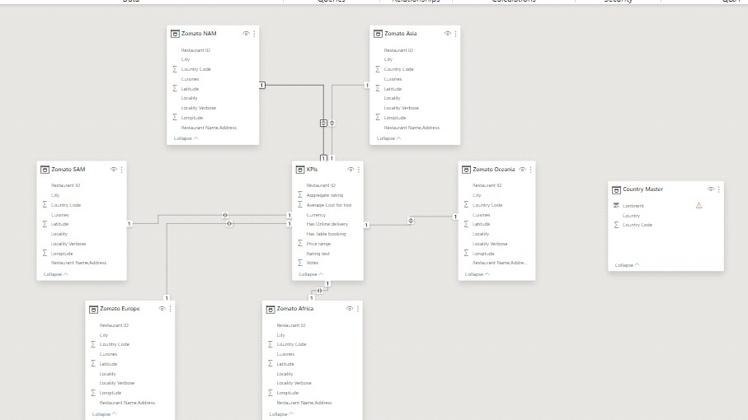

MANAGE RELATIONSHIP

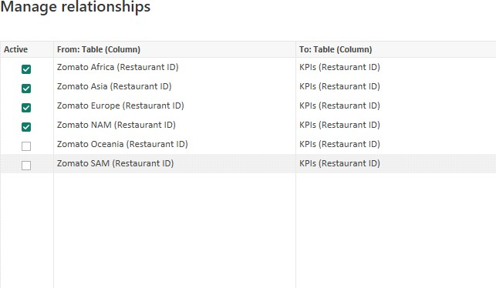

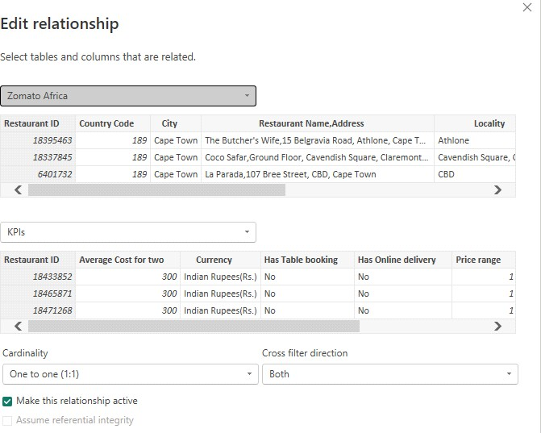

##### Modelling for Restaurant and country

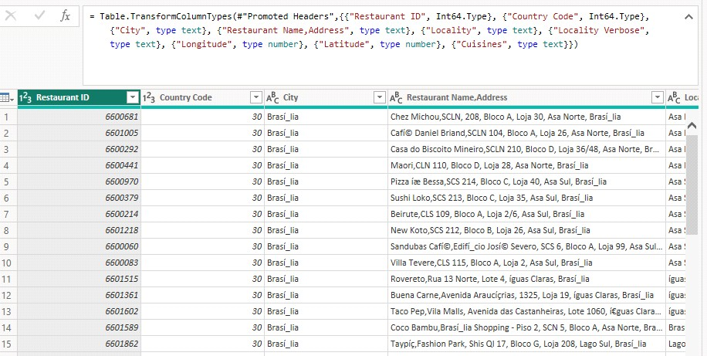

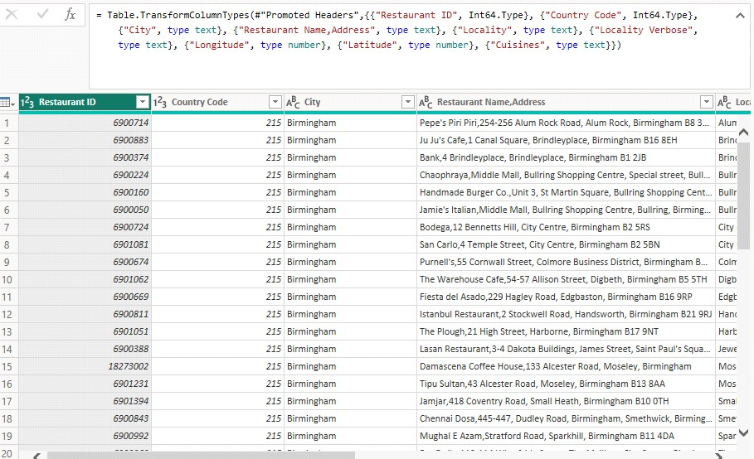

**Replacing values**

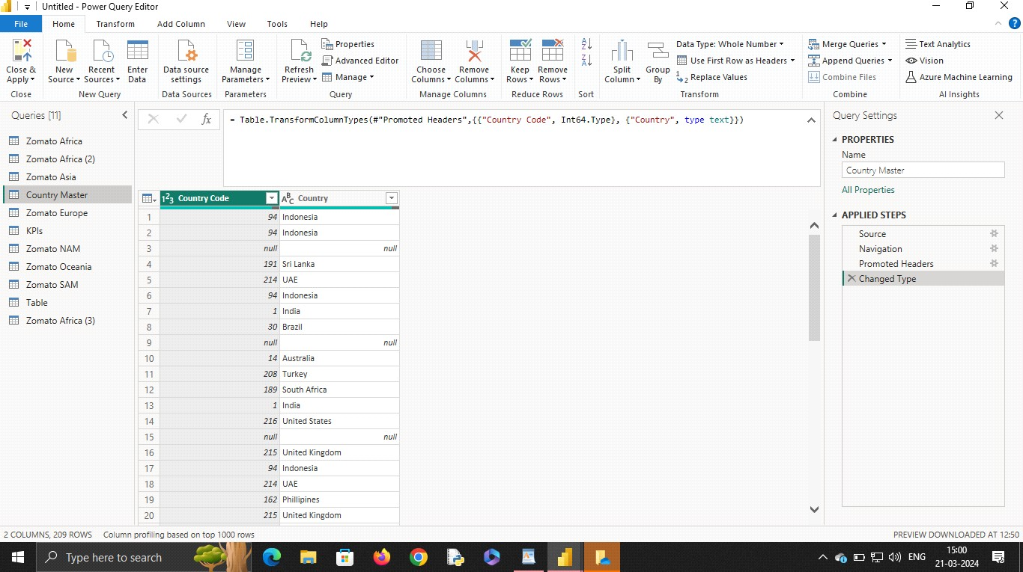

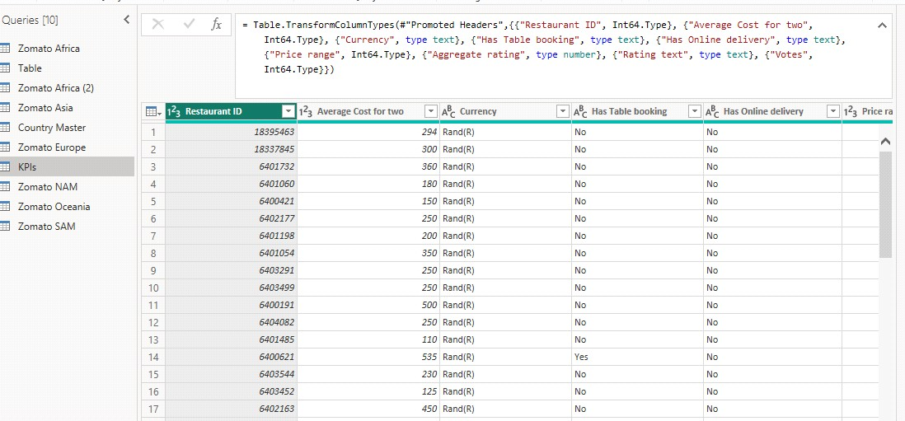

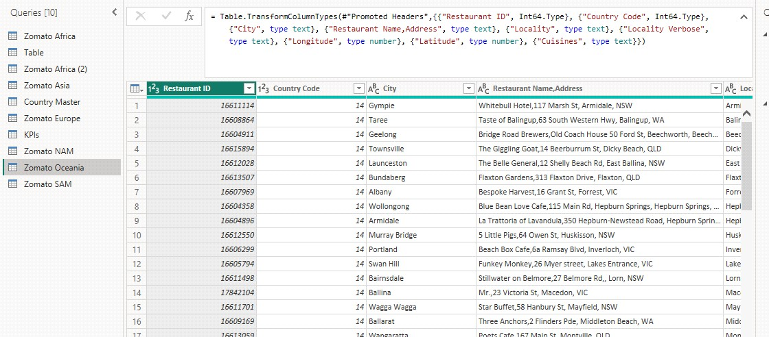

# Dashboard

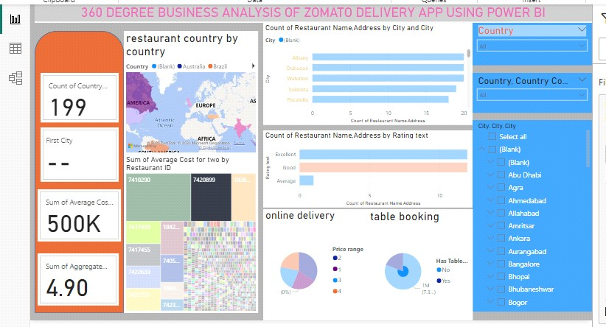

## CONCLUSION

This comprehensive business analysis of Zomato's online delivery app has shed light on its strengths and weaknesses. Here's a roadmap for Zomato to capitalize on the potential we've identified:

Refine the User Experience: Continuously improve app features based on user data to enhance discoverability, streamline ordering, and offer multiple payment options.

Strengthen Restaurant Partnerships: Develop win-win commission structures, provide marketing support, and offer data analytics to help restaurants optimize their online presence.

Embrace Innovation: Stay ahead of the curve by exploring technological advancements like AI- powered recommendations and delivery drones.

Prioritize Customer Retention: Implement targeted marketing campaigns and loyalty programs to cultivate a strong user base.

Adapt to Market Dynamics: Monitor competitor strategies and emerging trends to maintain a competitive edge.

By effectively addressing these points, Zomato can solidify its position as a leader in the online food delivery market. This will ensure continued growth, a loyal customer base, and a thriving partnership network with restaurants.

### FUTURE SCOPE

Hyper-Personalization: Analyzing user data to personalize recommendations, suggesting dishes based on past orders and dietary preferences, and offering targeted promotions.

Delivery Optimization: Leveraging data analytics and AI to optimize delivery routes, predict peak demand periods, and improve delivery efficiency.

Integration with Automation & Robotics: Exploring partnerships with drone delivery companies or autonomous vehicles for faster deliveries in specific areas.

Focus on Sustainability: Analyzing the environmental impact of deliveries and exploring solutions like partnering with eco-friendly packaging companies or offering carbon-offset options.

Subscription & Loyalty Programs: Developing tiered subscription models offering additional perks like free deliveries or exclusive discounts to increase customer loyalty.

Expansion Beyond Food Delivery: Analyzing the potential for delivering groceries, medicines, or other essentials through partnerships with diverse vendors.

Data Security & Privacy: Implementing robust data security measures and building trust with users regarding data collection and usage practices.

LINK

<https://github.com/Subha703/Subha703>